Thriving on Challenges
Nova-Rose, you excitedly came running towards me. Your wairua was beaming as you called out "Quick Kelly, come and watch me! I have learnt something new". Instantly, I was intrigued and I quickly followed you as you led me to the climbing trees.
"I have been learning this for weeks!" you exclaimed! The look on your face was simply priceless; you were beaming with mana (pride), exuberance and enthusiasm about your achievement. I watched as you climbed the tree, hung onto the rope, placed your feet up against the trunk and inched your feet higher and higher until you could lean backwards - hanging upside down!
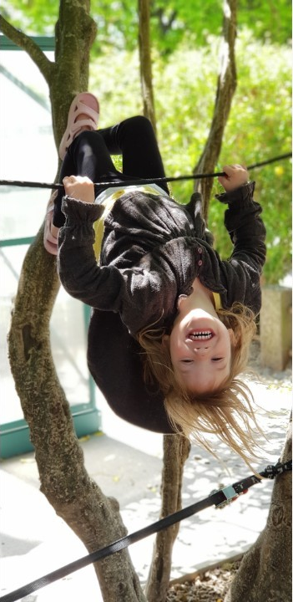
I was impressed by how self-reflective and aware you were of this achievement. And, it felt special that you chose to share this achievement with me. "I did it, I did it" you repeated with joy. "You must feel so proud of yourself....practice always makes progress" I said to you. "I'm so happy" you replied with glee.
"I'm so proud of myself" you told me. Nova-Rose, these words are like music to my ears and as a teacher they fill me with absolute joy.
"I loved watching you learn how to do that, Nova-Rose. I wonder what you will learn next" I posed to you. You went quiet and I could almost see your brain ticking away. Then you confidently stated that the next thing you will learn is how to lift your legs over the top rope and you explained that this is what another child (Honor) does and you have been watching her. Then you explained how one day you will eventually learn to flip yourself over on the rope, like her. "But that will be a bit scary" you explained. Interesting how something a bit scary can still be deeply compelling. Yet again, I was amazed by your ability to think ahead, set your next goal, highlighting your growth mindset (your awareness that abilities are gained through dedication and hardwork). This mindset helps to foster your love for learning and builds your resilience.
As your teachers, we are thrilled to see you engaging in self directed learning, setting your own goals and pursuing with difficulty - learning that anything is achievable and believing in your potential to gain new skills over time.
To me, this learning story reflects some of your families aspirations for you, Nova-Rose. These aspirations are for you 'to feel completely supported by those who you love you; to be truly who you are authentically and holistically; to develop a deep resilience from the love and care you receive; and to love, adore, trust and know yourself'. Seeing connecting links between what you are doing at the centre and the aspirations your family have for you is deeply meaningful.
Nova-Rose to support you we will continue to notice and recognise when you attempt your next physical challenge and whilst you may not be successful straight away, we will continue to remind you that 'practice makes progress' and every time you practice your muscles and body are getting stronger. Our focus will be on your efforts, your thinking and use of strategies, your persistence and courage. If we use praise, we intentionally use 'process praise' which keeps the focus on the process being important rather than the outcome. This will continue to foster your growth mindset and resilience.
"Good learners do not grow by being protected by difficulty, but by engaging with it, and thereby developing their skills" –Guy Claxton
Comments:
Shane Hantler on Nov 14, 2018 Such an amazing adventurer.
David Steele on Nov 14, 2018 Good old Nova, she loves the physical challenges.
David Steele on Nov 14, 2018 Girl on Wire!
Bex Thompson on Nov 15, 2018 I adore this story....I could feel the pride radiating from Nova Rose as I read the story. Congratulations Nova Rose.
Kate Steele on Nov 16, 2018 I wanted to cry with happiness when hearing how awesome you felt Nova about your achievement after practice. So proud of you.
Story date: 2 Nov 2018. Added by: Kelly Abraham.

